FOR IMMEDIATE RELEASE
DATE: October 5, 2021
CONTACT: Dave Meisinger, dmeisinger@cmeec.org, (860) 889-4088
RE: CMEEC Employees Awarded for Performance & Generosity in 2020-2021 United Way Campaign

NORWICH – Employees at Connecticut Municipal Electric Energy Cooperative (CMEEC) raised funds for The United Way of Southeastern CT, one of the region’s biggest fundraisers for local support which is then invested in a vital network of local health and human service programs and initiatives that work together to provide a safety net of services that create real, lasting change in New London County. For their generosity and fundraising performance during their 2020-21 campaign, CMEEC was awarded the Live United Award.
“CMEEC was chosen for our Employee Campaign Performance of the Year award for running an exemplary campaign with management support and endorsement,” said Dina Sears-Graves, President and CEO of United Way of Southeastern Connecticut. "The employees show that they Live United through their outstanding commitment to community, especially during these challenging times as we all work together to recover from the pandemic."

CMEEC offered various non-monetary incentives for employees who donated, resulting in a 31% increase in employee giving during the pandemic.
“I want to thank everyone who chose to participate in this campaign. This award is particularly important because it is solely a result of employee contributions,” CMEEC CEO David Meisinger said. “Whether through United Way or other means, it is important to give back to our local communities, which is actually one of the key principles upon which CMEEC was founded.”
CMEEC employees have participated in the United Way of Southeastern CT fundraising campaign for over 20 years. CMEEC’s 27 employees support The United Way’s mission to “inspire and coordinate the generosity and commitment that sustains a united, thriving community.”
Established in September 1976, CMEEC is responsible for the financing, acquisition and construction of electric generation resources and the implementation of power supply contracts on behalf of its municipal electric utility members: Bozrah Light & Power, Jewett City Department of Public Utilities, Groton Utilities, Norwich Public Utilities, South Norwalk Electric and Water and The Third Taxing District of Norwalk Electric Division. CMEEC also supplies the wholesale power requirements of the Mohegan Tribal Utility Authority. Through its member utilities, CMEEC provides low-cost, reliable electricity to more than 50,000 customers in Connecticut.
###

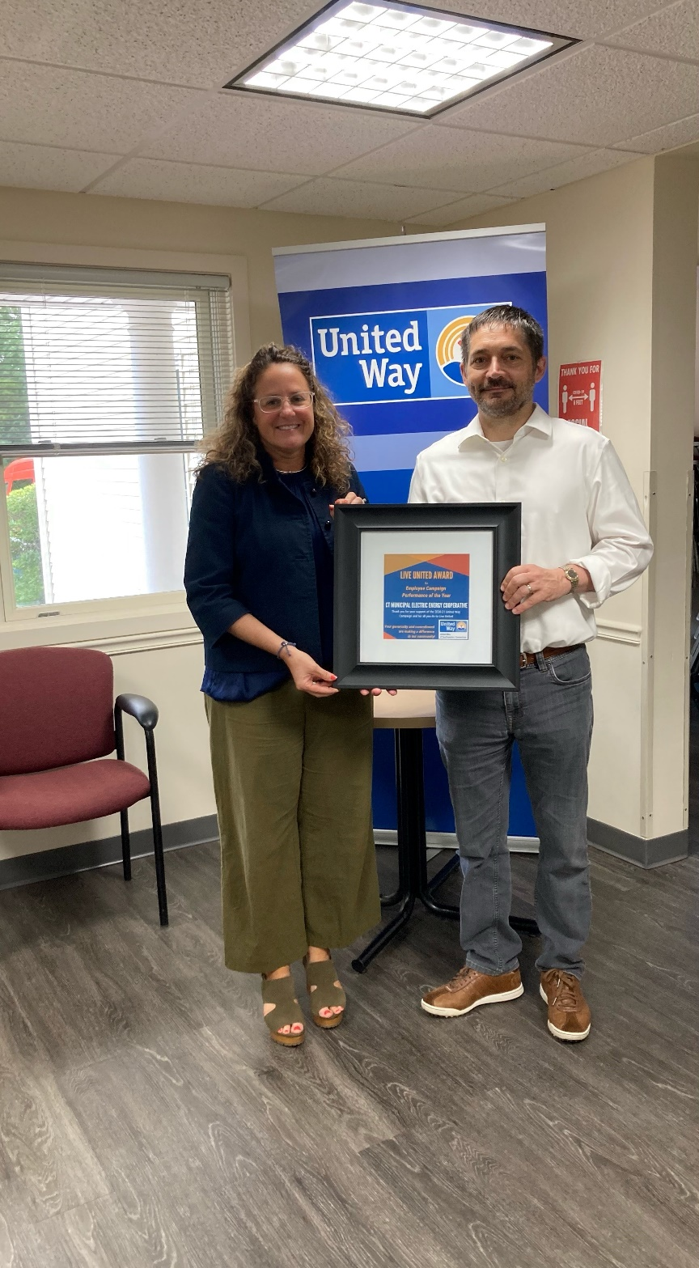
Dina Sears-Graves, CEO of the United Way of Southeastern CT
Presenting CMEEC Employees’ Award to
David Meisinger, CMEEC’s CEO

